WEB SITE under SVN Server (https://svn.cs.uh.edu/svn/cosc4351/team1), CCNET Build Server (on cruise.cs.uh.edu), and IIS Web Server(on cruise.cs.uh.edu) SETUP:

**Step 1:** Get a copy of the SVN for team1. **SVN Checkout**

team1

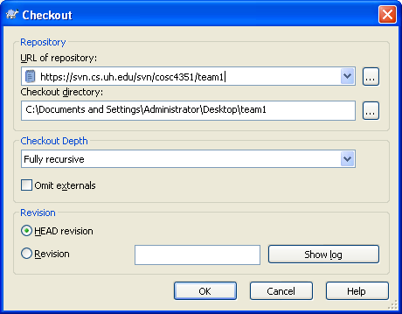

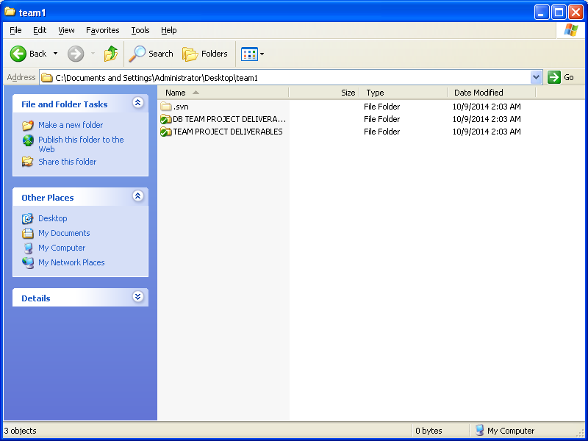

**Step 2: ONLY FIRST TIME to add the TEAM1OSCS PROJECT**

Creating **TEAM1OSCS** EMPTY VS 2010 C# MVC2, in the LOCAL COPY OF THE team1 SVN repository.

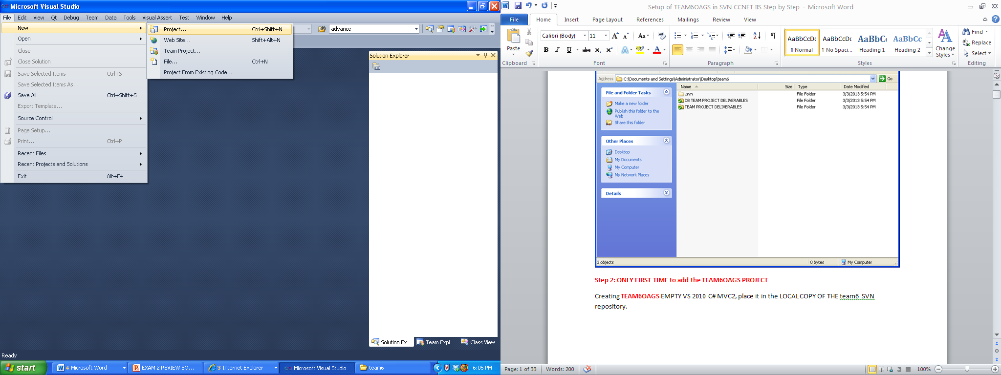

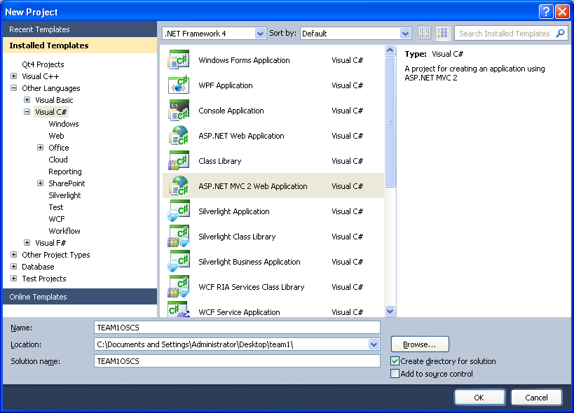

**Change to TEAM1OSCS**

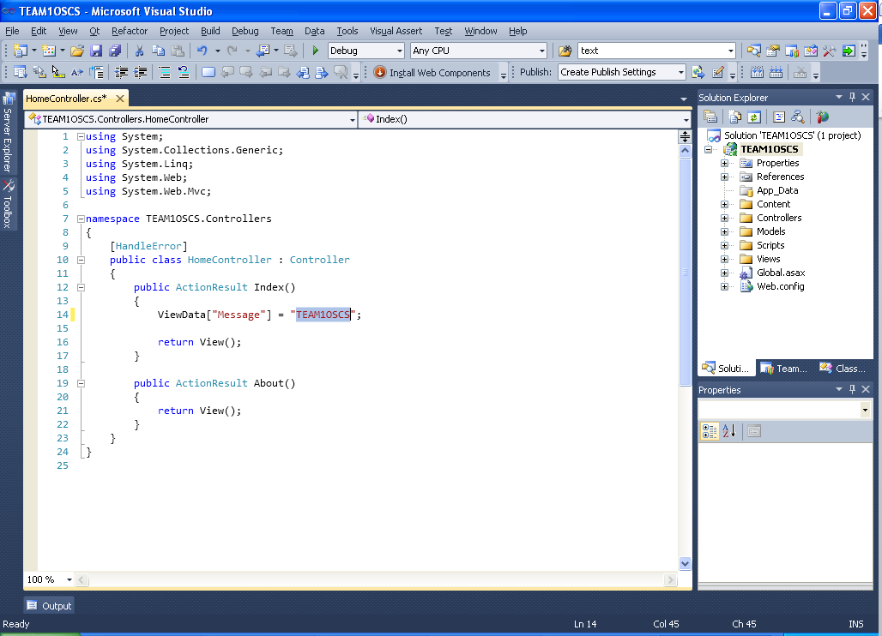

**Change Master Page**

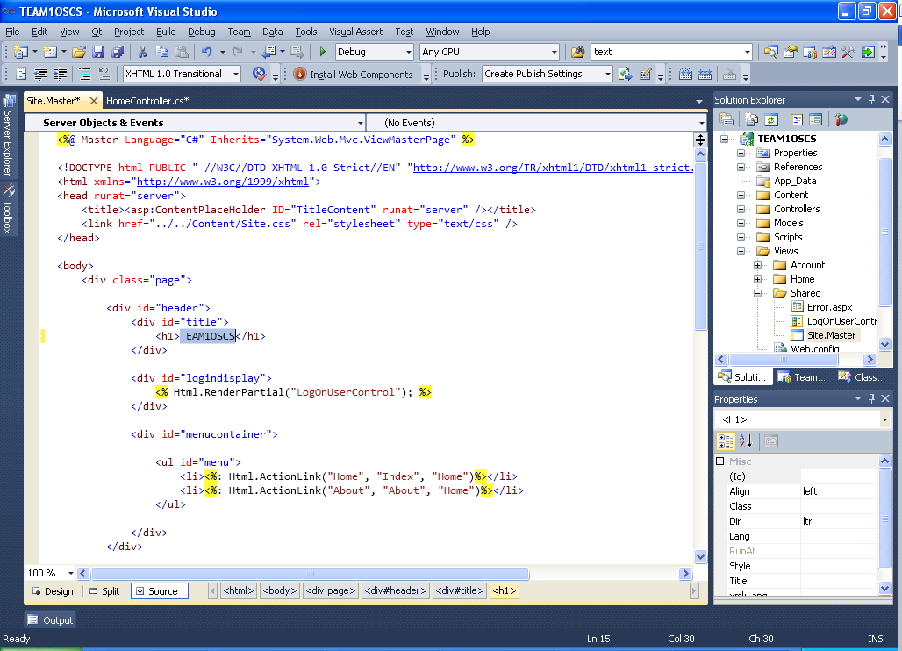

**BUILD and RUN**

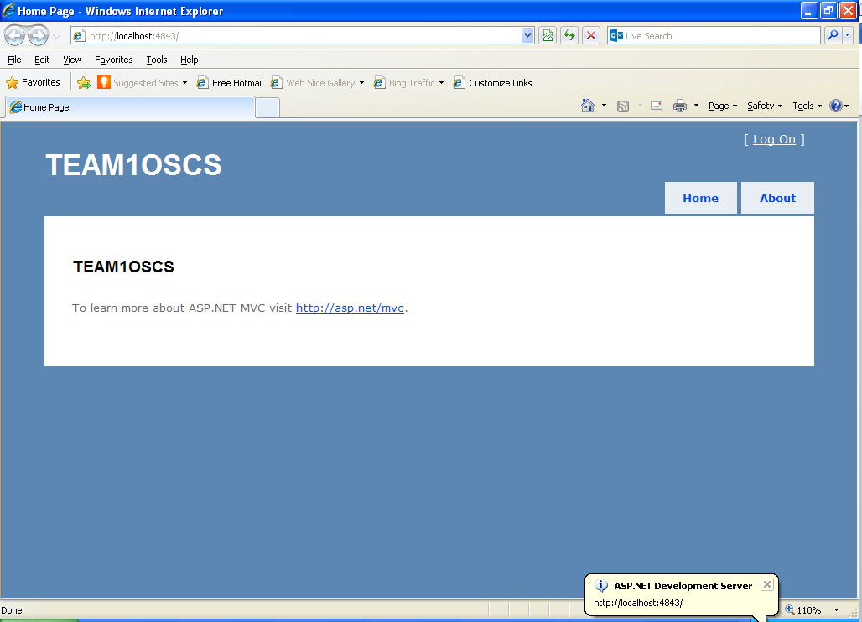

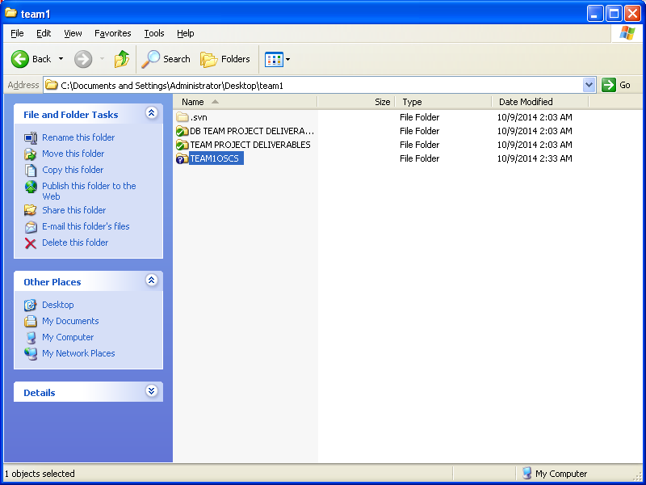 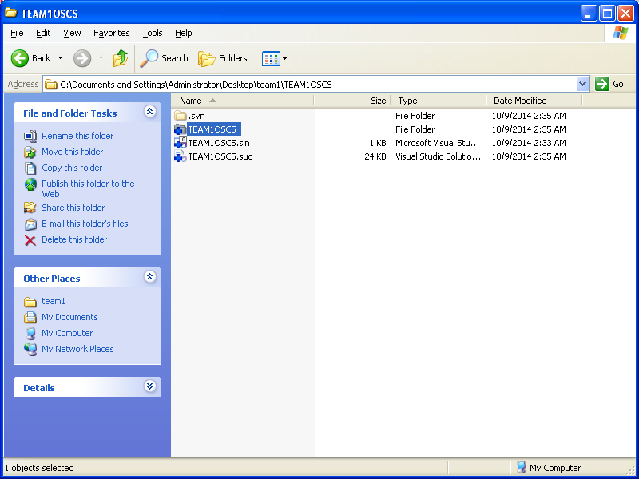

**Step 3:** **SVN ADD** and **SVN COMMIT** to SVN

**SVN ADD**

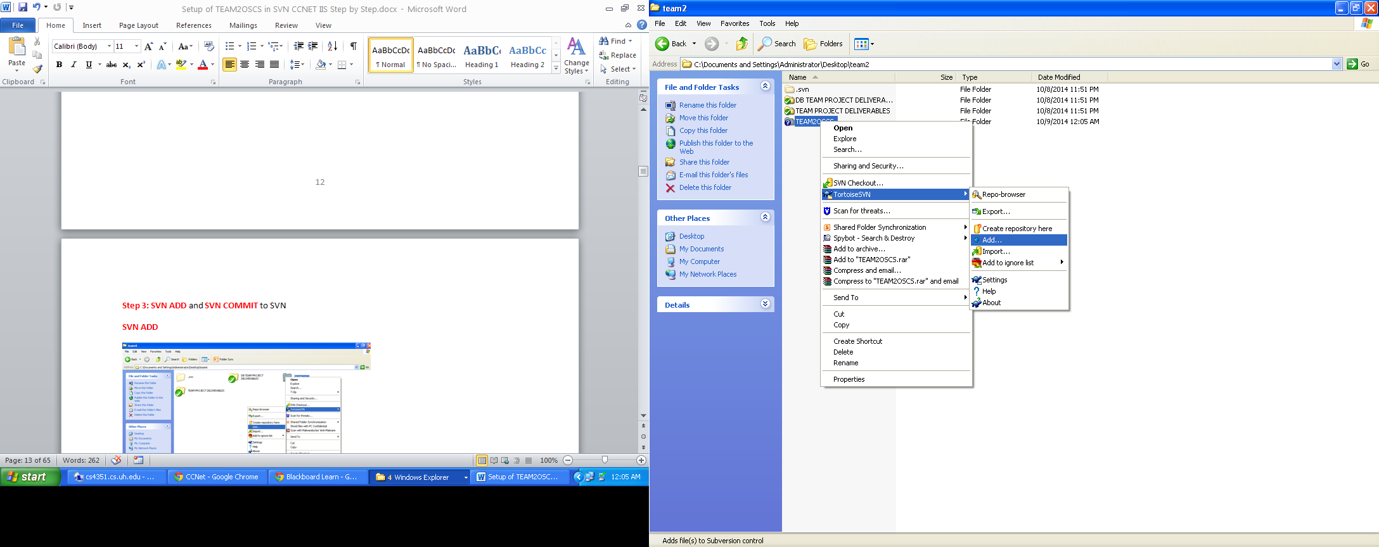



**SVN COMMIT**

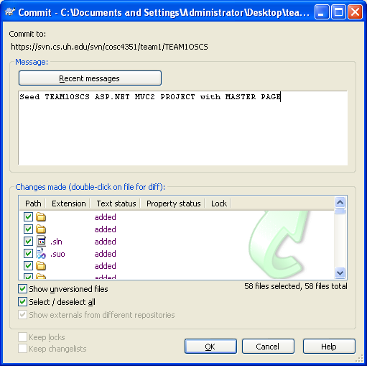

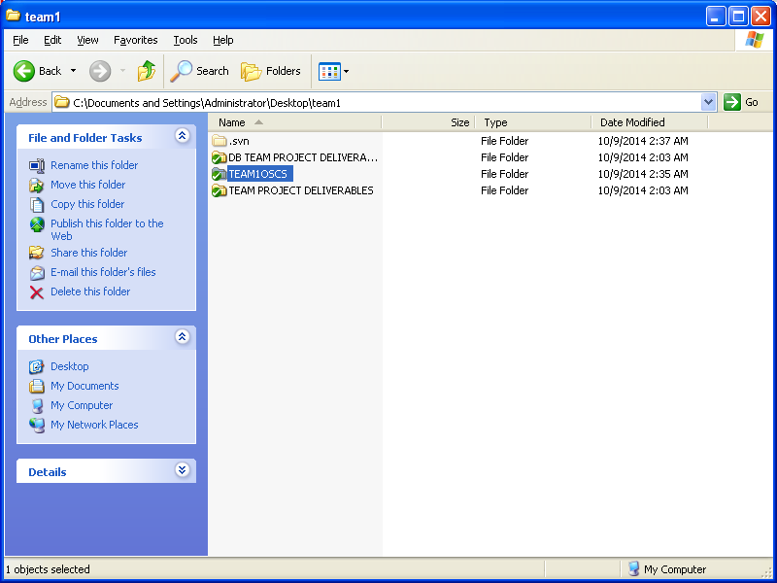

**Step 4**: Add **TEAM1OSCS** to **CCNET** on **cruise.cs.uh.edu**

**CCNET** Build Server is in

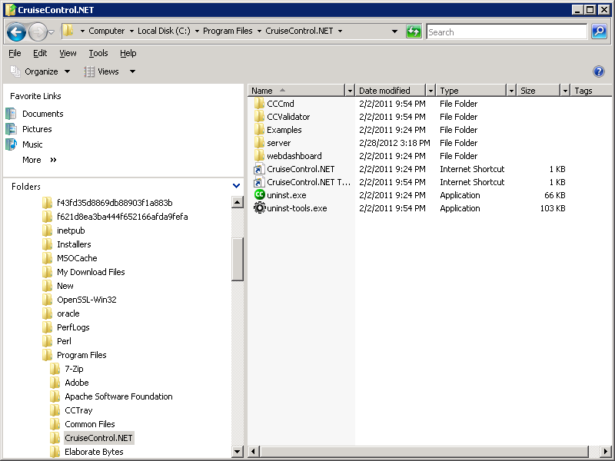

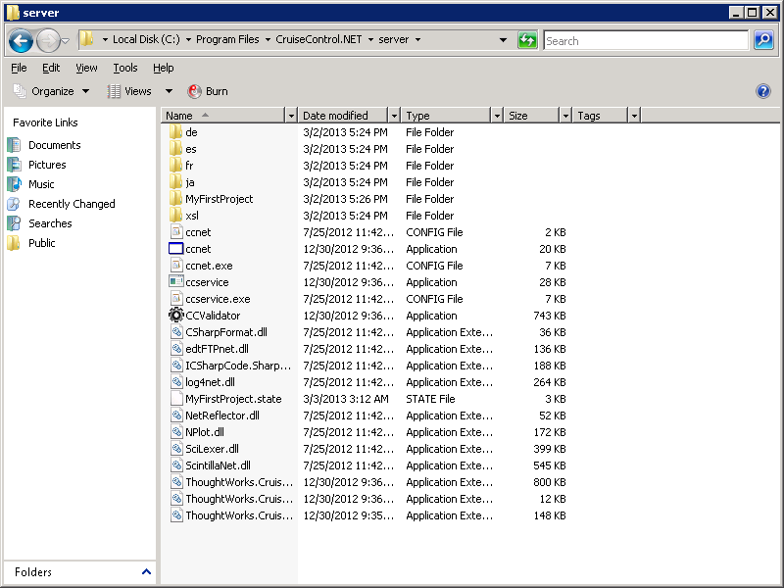

**ccnet.config** file is here

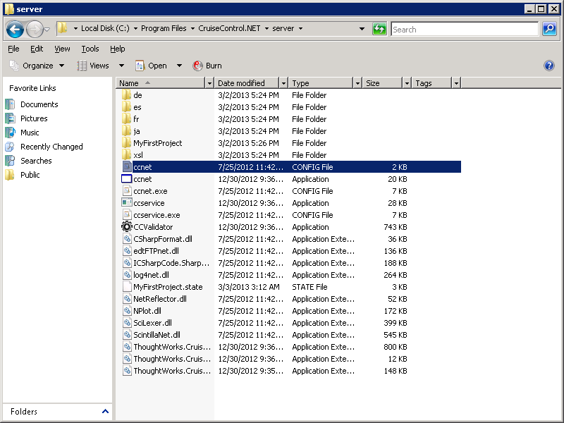

Edit **ccnet.config** to add **TEAM1OSCS** to the **CCNET** server and **IIS**

<!-- TEAM1OSCS ASP MVC2 C# -->

<project name="TEAM1OSCS">

<workingDirectory>C:\Program Files (x86)\CruiseControl.NET\server\TEAM1OSCS

\WorkingDirectory</workingDirectory>

<artifactDirectory>C:\Program Files (x86)\CruiseControl.NET\server\TEAM1OSCS</artifactDirectory>

<sourcecontrol type="svn">

<trunkUrl>https://svn.cs.uh.edu/svn/cosc4351/team1/TEAM1OSCS</trunkUrl>

<executable>C:\Program Files (x86)\Subversion\bin\svn.exe</executable>

<username>**\*\*\*\*\*\*\***</username>

<password>**\*\*\*\*\*\*\***</password>

</sourcecontrol>

<triggers>

<intervalTrigger seconds="120" buildCondition="IfModificationExists" />

</triggers>

<publishers>

<modificationHistory />

<xmllogger />

<statistics />

</publishers>

<prebuild>

<msbuild>

<executable>C:\Windows\Microsoft.NET\Framework

\v4.0.30319\MSBuild.exe</executable>

<projectFile>C:\Program Files (x86)\CruiseControl.NET\server\TEAM1OSCS

\WorkingDirectory\TEAM1OSCS.sln</projectFile>

<targets>Build</targets>

<timeout>900</timeout>

</msbuild>

<exec>

<executable>C:\Windows\System32\cmd.exe</executable>

<buildArgs>/c "rmdir "C:\inetpub\wwwroot\TEAM1OSCS" /q /s "</buildArgs>

</exec>

<exec>

<executable>C:\Windows\System32\cmd.exe</executable>

<buildArgs>/c "mkdir "C:\inetpub\wwwroot\TEAM1OSCS""</buildArgs>

</exec>

<exec>

<executable>C:\Windows\System32\cmd.exe</executable>

<buildArgs>/c "%systemroot%\System32\xcopy "C:\Program Files (x86)\CruiseControl.NET

\server\TEAM1OSCS\WorkingDirectory" "C:\inetpub\wwwroot" /Y /e"</buildArgs>

</exec>

</prebuild>

</project>

Start CCNET

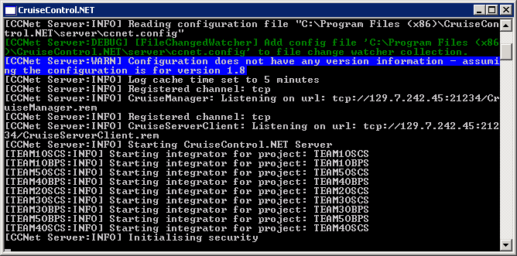

Do a fresh SVN Checkout, first time ONLY!

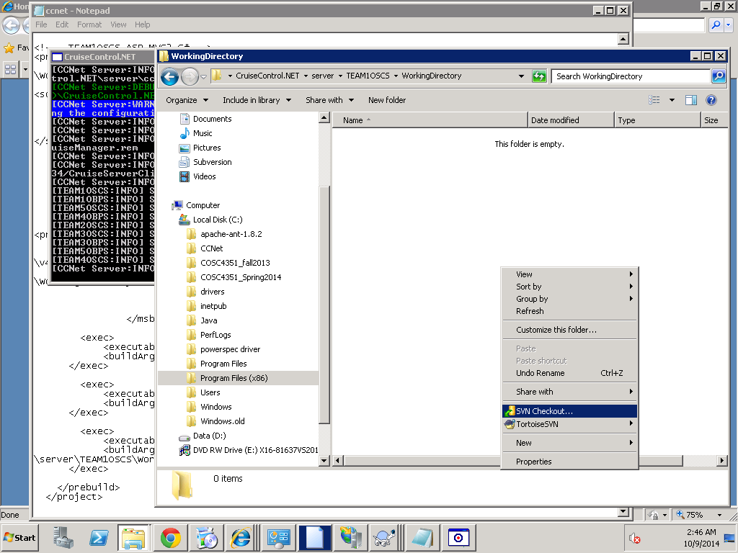

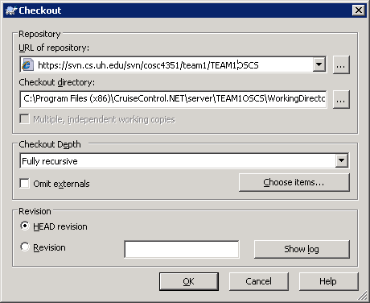

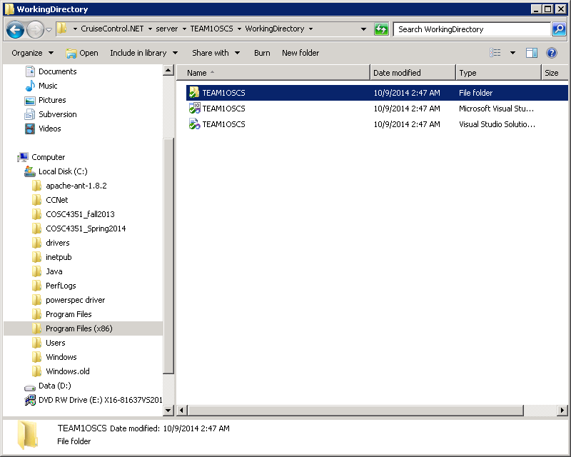

Restart the ccnet Build Server **ccnet.exe**:

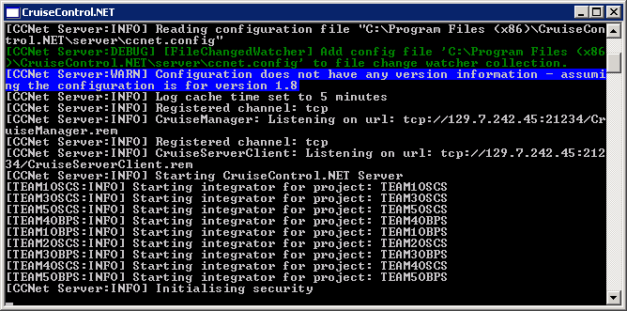

Refresh **ccnet web site** **cs4351.cs.uh.edu/ccnet**:

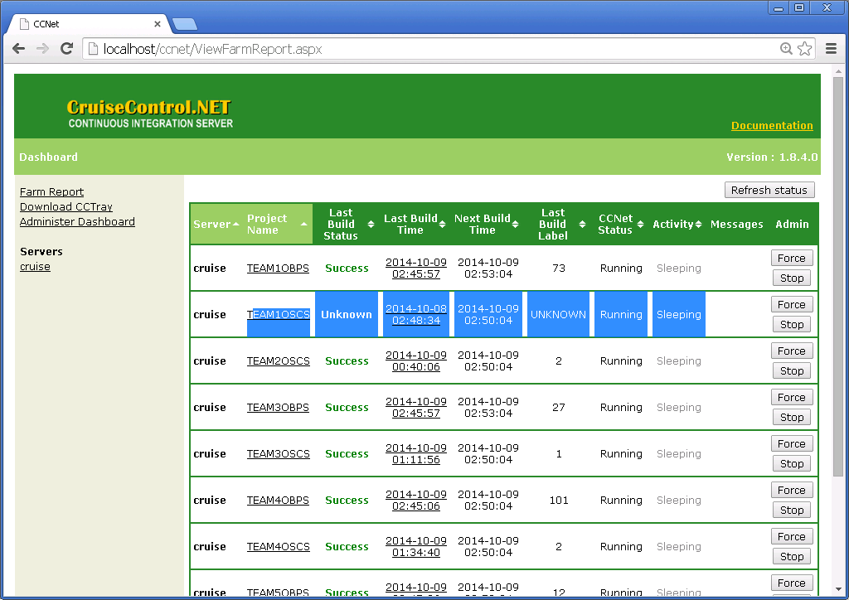

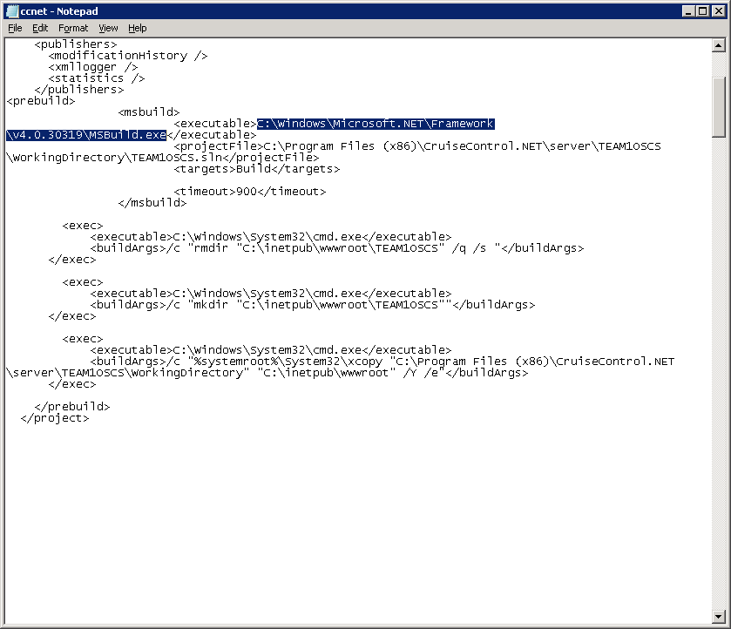

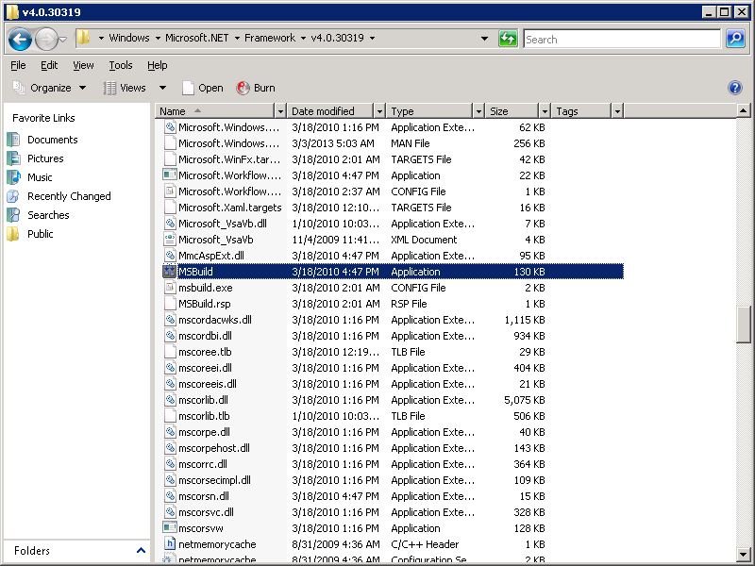

This build will fail unless this folder exists, thus it can be removed.

Let us create the folder in inetpub/wwwroot:

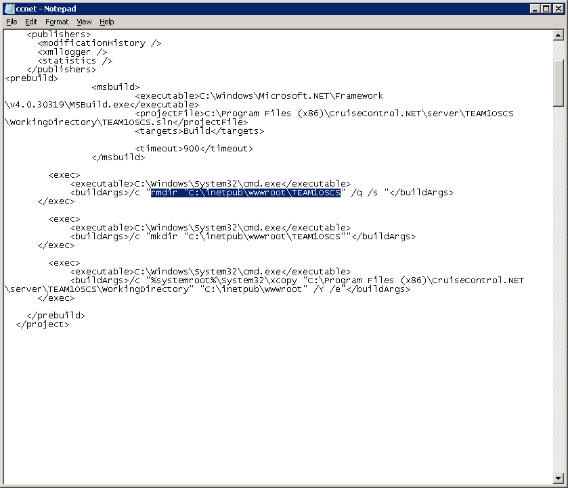

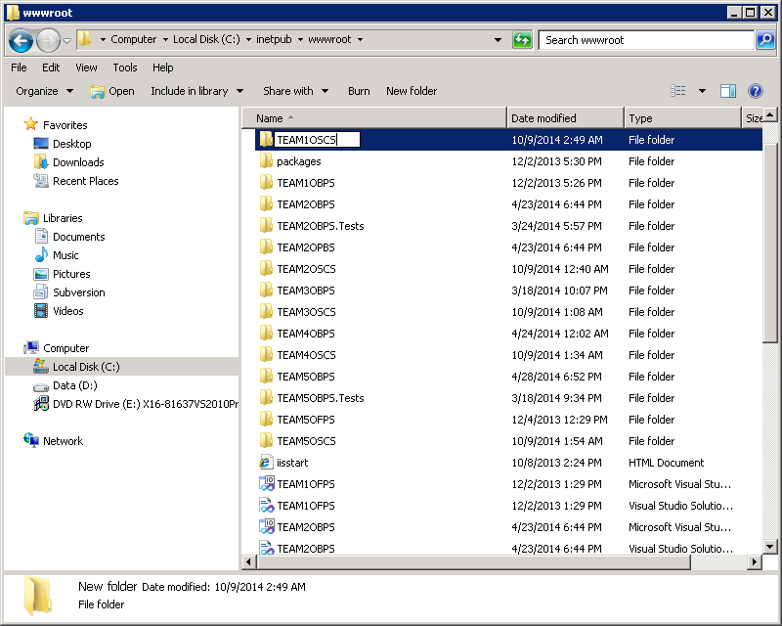

Force Build in CCNET

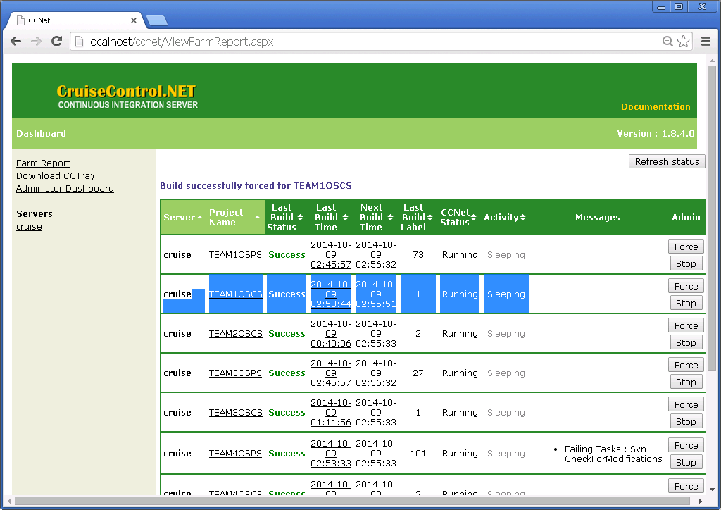

**Success!!**

**View Build Log**

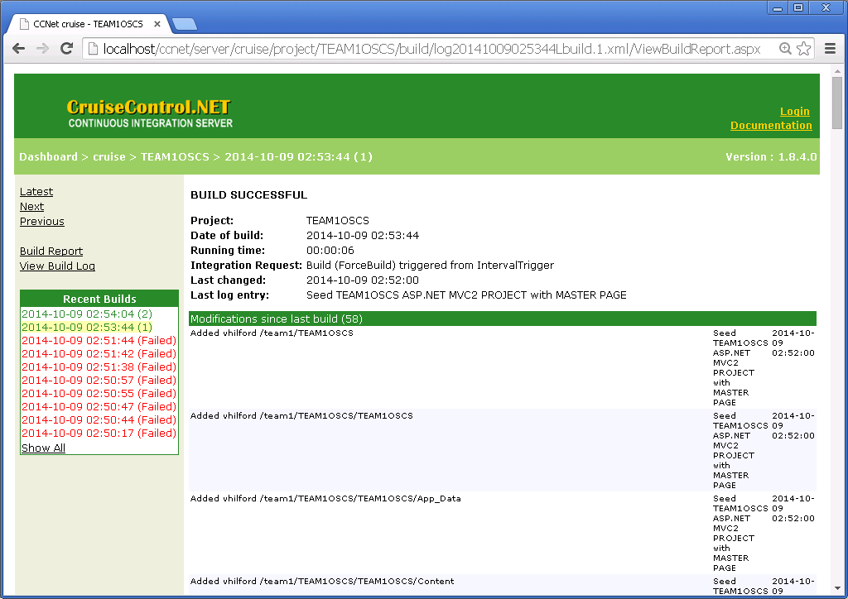

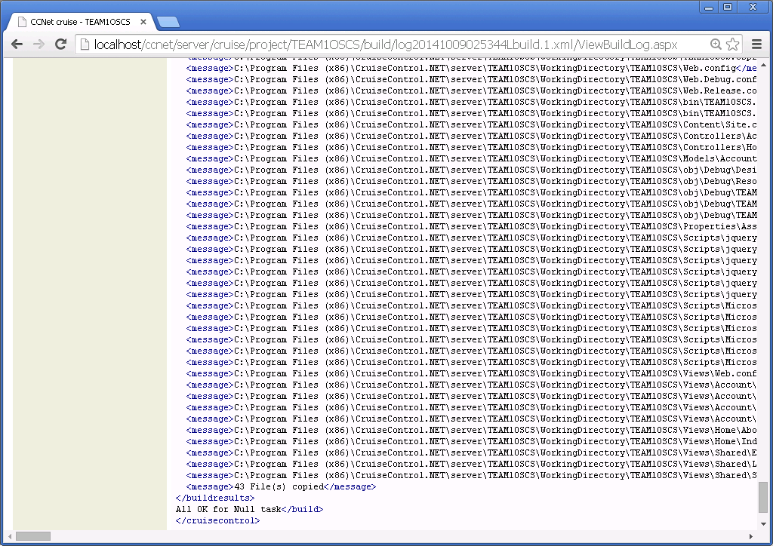

**IIS Web Server Setup**:

Create a Virtual Directory

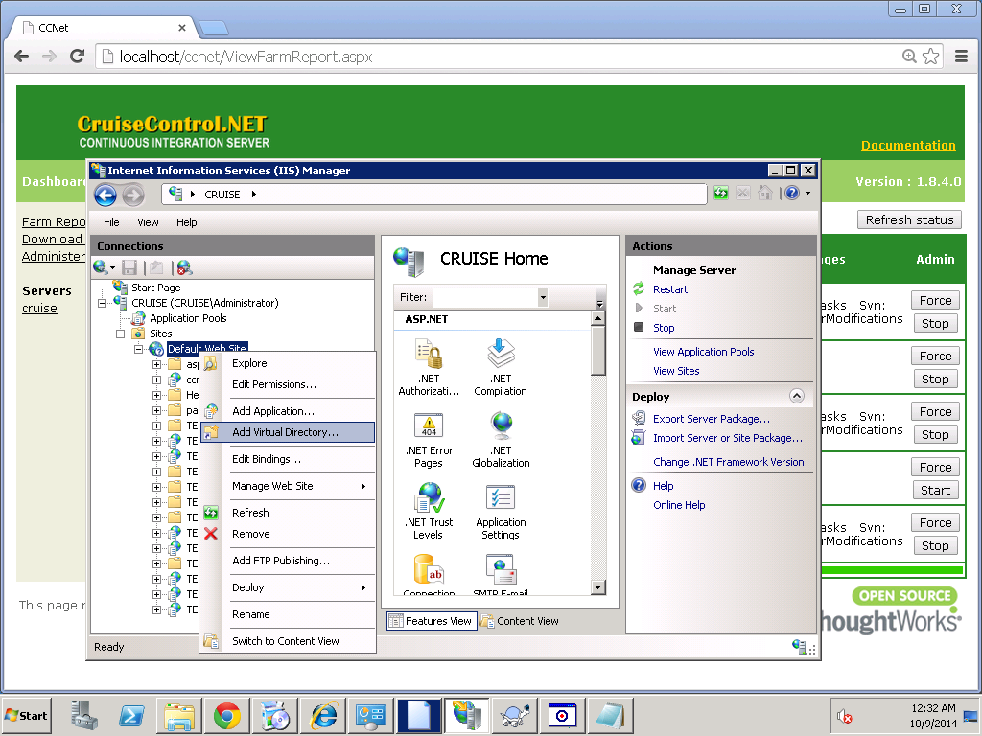

**C:\Program Files (x86)\CruiseControl.NET\server\TEAM1OSCS\WorkingDirectory\TEAM1OSCS**

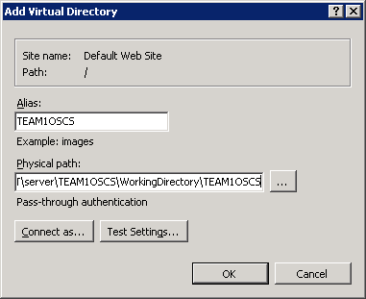

Convert to Application

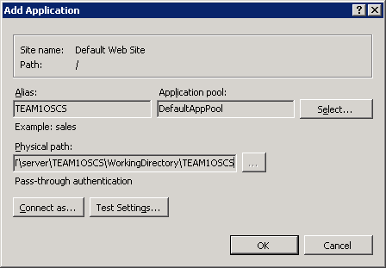

Browse from inside IIS  
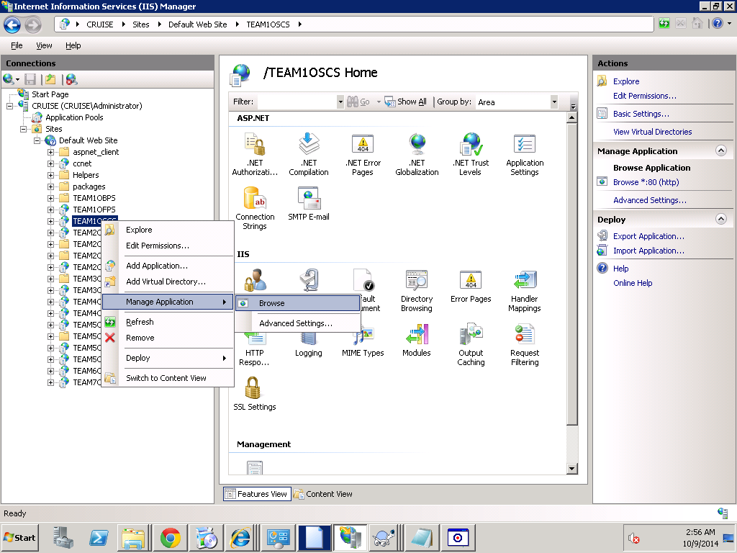

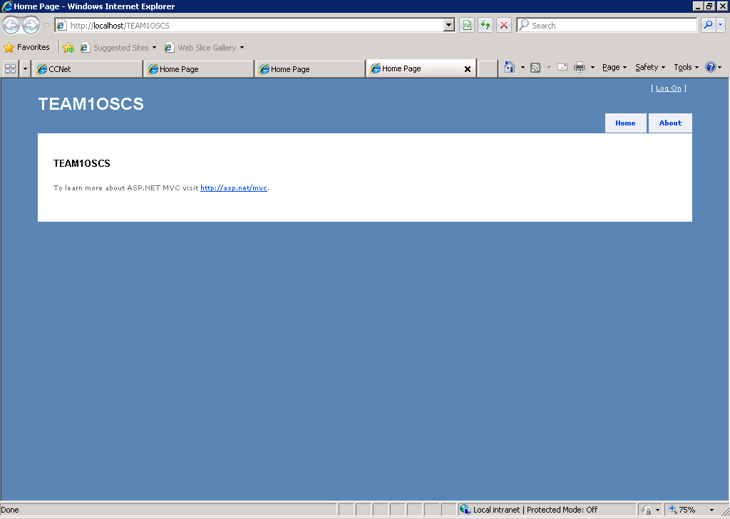

OR RUN IT FROM ANY **BROWSER** as:

**http:cruise.cs.uh.edu/TEAM1OSCS**

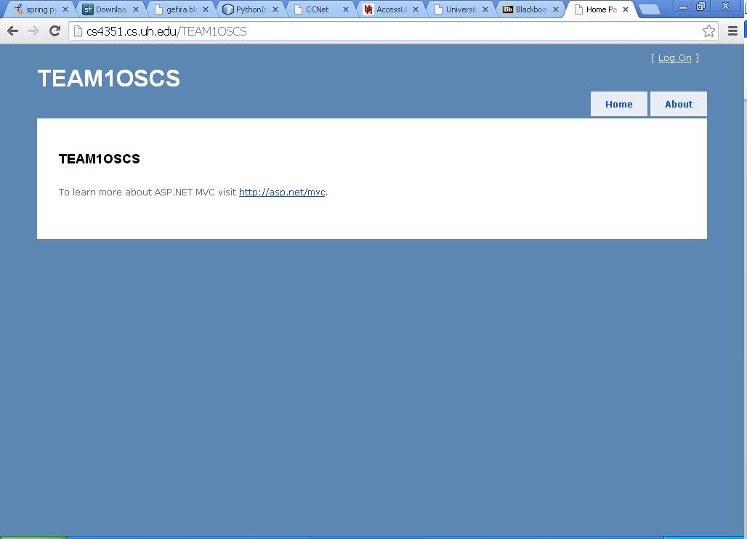

**WOW!**